To: Full Service Medicaid County (Portal) Providers
Re: Session Notes Documentation & Signature Requirements for Medicaid
McGuinness has recently participated in several SED Medicaid Document Reviews with various counties. The following issues have been flagged in each of these reviews (Setting/Location and Signatures), which means during an official audit, the county could incur fines.
The information noted below will assist service providers with entering Medicaid-compliant information into the Setting and Location Fields on the Portal Session Note and the Signature Field in the Portal Profile.
- Medicaid-Compliant Session Notes
The Setting and Location Fields together should give enough information for an auditor to determine “where” the child’s therapy took place (Please see the Medicaid Citations noted at the end of this email).

If the information entered into these two fields is too vague to determine where the service took place, the session note will not meet Medicaid requirements.
Listed below are some examples (Specific Enough/Not Specific Enough) for the Setting/Location on the session note.
Not Specific Enough  (Does not meet Medicaid Requirements) | Specific Enough  (Meets Medicaid Requirements)
Setting: School  Location: Therapy Room | Setting: Preschool  Location: ABC Preschool, 123 Main St., Albany, NY
Setting: Universal Pre-K  Location: Preschool | Setting: Universal Pre-K  Location: ABC Preschool, Classroom 3
Setting: Preschool  Location: Sensory Gym | Setting: Preschool  Location: ABC Preschool, Sensory Gym
Setting: Community Setting  Location: Classroom A | Setting: Community Setting  Location: Classroom A, 254 South Main Street, Albany NY,

Setting Field: The list below are appropriate Settings that could be entered into the Setting Field on the Portal Session Note:

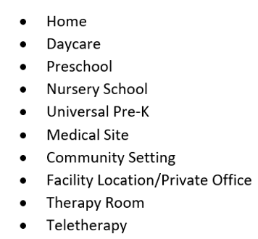

Location Field: The Location Field on the Session Note should indicate a specific location for the Setting (or site; such as the name of the school/location and/or address of school/location) as shown in the list above. The Location Field on the Session Note is a mandatory field for Full-Service Medicaid Counties. In order to submit billing vouchers to the county, the location field must be completed on the session note.

Service Providers using the Portal have the ability to set up Session Notes “Defaults” for the Portal Session Note. The following fields can be entered once (during the default set-up) and will populate each time a subsequent session note is entered.

Default Fields:
  - Setting
  - Location
  - CPT Code(s)
  - ICD Code(s)
If any of the default settings do not apply to a specific session note after default settings are set up, the specific default setting can be deleted (on the current session note) and replaced with the appropriate information for the specific session. It is highly recommended that defaults be setup on session notes.
This link (https://support.cpseportal.com/kb/a243/setting-up-defaults-in-your-caseload.aspx) will bring you to a Knowledge Base Article that describes how to set up session notes defaults. If you require additional assistance in setting up defaults, please send an email to Medicaid@cpseportal.com. Someone from the Medicaid Team will assist you.
Medicaid Questions & Answers (# 105 & 164 / Setting & Location)
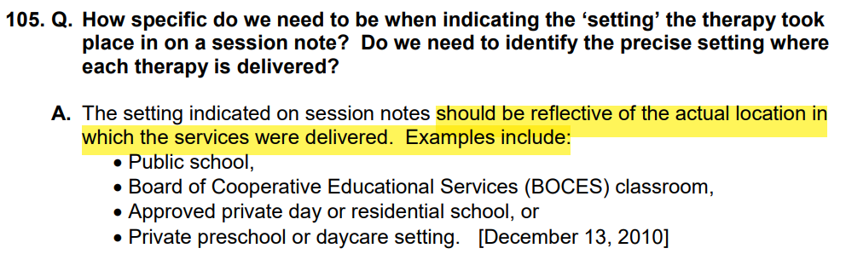
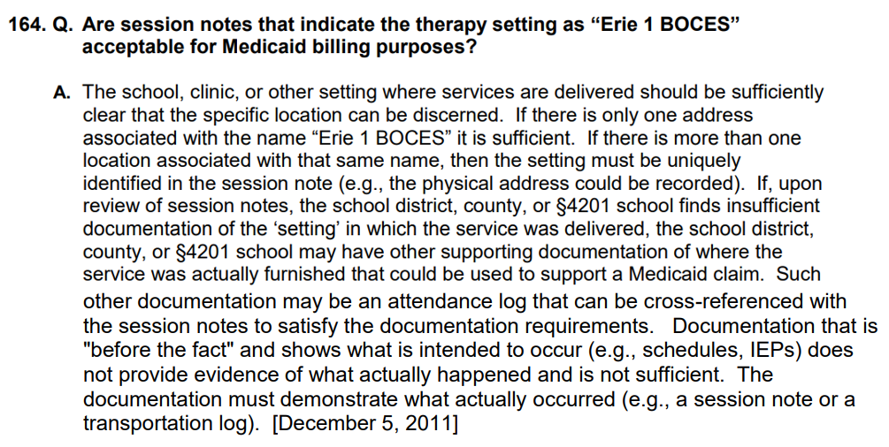

- Medicaid-Compliant Signatures
The information noted below will assist service providers with entering a Medicaid-compliant signature into their Portal Profile, which will be used to sign all session notes and digital speech recommendations.

As per Medicaid, licensed practitioners that sign Medicaid documentation must include their Name, Title, Signature and Credentials in their signature. If the signature does not include the name, title and credentials, the signature will not meet Medicaid requirements and could be flagged during an audit. Some of the session notes from recent SED Document Reviews have been flagged for not having “complete” signatures (Please see Medicaid Citation noted below).

An example of a Medicaid-compliant signature is shown below:

Shannon Stark, MA CCC/SLP
Name, Credentials, Title
Please review the signature entry in your Portal Profile. If the signature entry does not show your name, credentials and title, please modify and update the signature field as soon as possible.
This link (https://support.cpseportal.com/kb/a25/entering-signature-title-and-credentials.aspx) will bring you to a Knowledge Base Article that describes how to update your signature. If you require additional assistance in updating your signature, please send an email to Medicaid@cpseportal.com. Someone from the Medicaid Team will assist you.
Medicaid Questions & Answers (#25 - Signatures)
