To: Claims/EnterClaims Users
Re: Session Notes Documentation & Signature Requirements for Medicaid
McGuinness has recently participated in several SED Medicaid Document Reviews with various counties. The following issues have been flagged in each of these reviews, which means during an official audit, the county could incur fines.
- Non-Compliant Session Notes
  - The description entered for the Setting Field on the session note does not always meet Medicaid requirements. The Setting and Location fields together should give enough information for an auditor to determine “where” the child’s therapy took place (Please see Medicaid Citation noted at the end of this email). If the information entered into these two fields is too vague to determine where the service took place, the session note will not meet Medicaid requirements.
Listed below are some examples (Specific Enough/Not Specific Enough) for the Setting/Location on the session note.
Not Specific Enough  (Does not meet Medicaid Requirements) | Specific Enough  (Meets Medicaid Requirements)
Setting: School  Location: Therapy Room | Setting: Preschool  Location: ABC Preschool, 123 Main St., Albany, NY
Setting: Universal Pre-K  Location: Preschool | Setting: Universal Pre-K  Location: ABC Preschool, Classroom 3
Setting: Preschool  Location: Sensory Gym | Setting: Preschool  Location: ABC Preschool, Sensory Gym
Setting: Community Setting  Location: Classroom A | Setting: Community Setting  Location: Classroom A, 254 South Main Street, Albany NY,

Claims clients should ensure that the Setting and Location Maintenance Screens are entered with the approved options. If these options are entered correctly, the therapist will have the information that they need (to select from) when entering their session notes in EnterClaims.

The settings shown below can be entered into the Setting Maintenance by going to: Maintenance>Misc. Maintenance>Miscellaneous Codes>Service Setting. You can Add or Delete from this screen by using the Add/Delete Buttons and then clicking the Save Button.

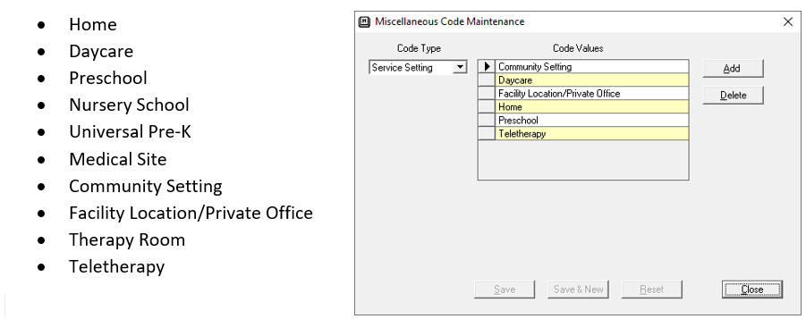

The specific locations for the setting types shown above should be entered into the Location Maintenance in Claims by going to: Maintenance>Misc. Maintenance>Location

The Location Field on the Session Note should indicate the specific location for the Setting (or site; such as the name of the school/location and/or address of school/location) as shown in the list above. The Location Field on the Session Note is a mandatory field for Full-Service Medicaid Counties. In order to submit billing vouchers to the county, the location field must be completed on the session note.

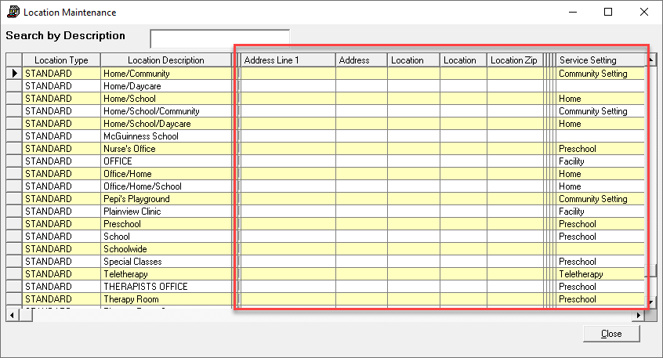

The Location and Alternate Location on the Enrollment should be filled in with the correct information. The information that is entered here will appear on the EnterClaims’ Session Note for the therapist. In the screenshot shown below, “Therapy Room” is not specific enough to determine where the service was provided. Therapy Room, ABC School is specific enough.

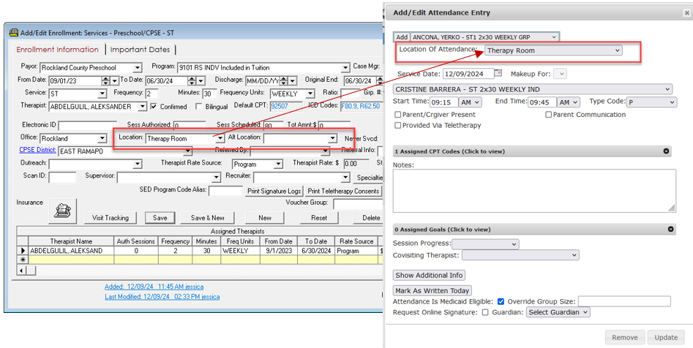

When the session note is signed, the therapist can see if the location is entered. The note should not be signed if the location field is missing information (as shown in the screenshot below). The service provider should reach out to the agency staff to have this information added (in Claims) prior to signing the session note. Billing cannot move forward with a blank Location Field (on the session note).

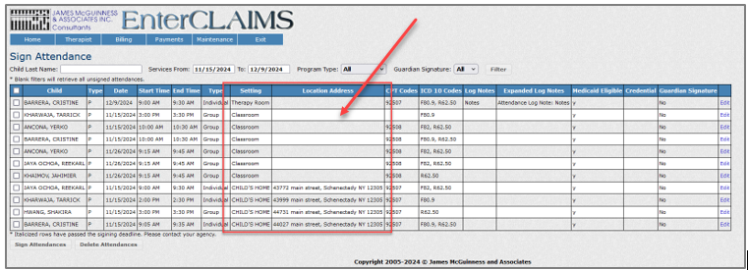

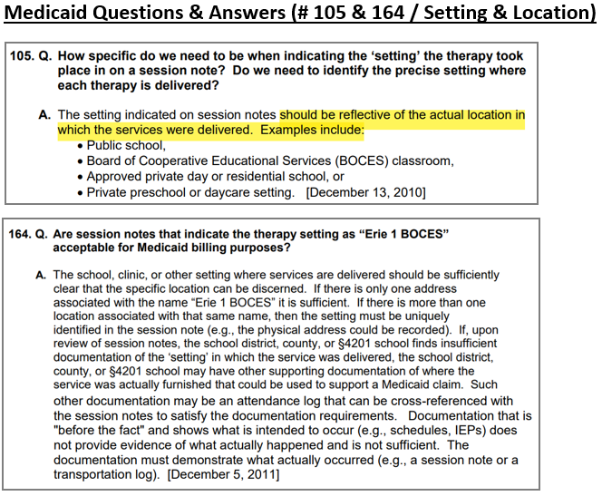

- Non-Compliant Signatures
Licensed practitioners that sign Medicaid documentation must include their Name, Title, Signature and Credentials in their signature. Some of the session notes from recent SED Document Reviews have been flagged for not having “complete” signatures (Please see Medicaid Citation noted below).

An example of a Medicaid-compliant signature is shown below:

Shannon Stark, MA CCC/SLP
Name, Credentials, Title
Claims clients should ensure that the Title Field on the Find Therapist Screen in Claims is filled in with a Medicaid-compliant signature (e.g., MA CCC/SLP).
If the Title Field is left blank on the Find Therapist Screen all session notes and digital orders that are signed in EnterClaims will not meet Medicaid requirements (and could be flagged in an audit).
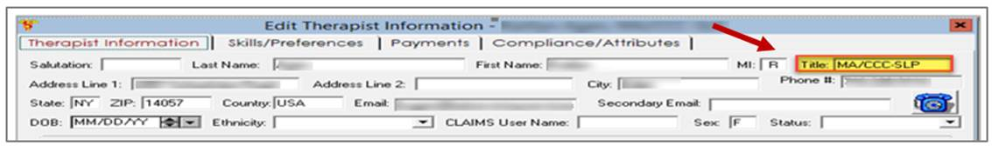

Medicaid Questions & Answers (#25 - Signatures)
