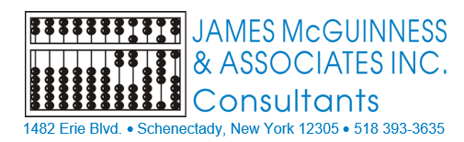

O P R A
(Ordering – Prescribing – Referring – Attending)
REFERENCE
GUIDE
(Updated September 2024)

Table of Contents

Page
Purpose of this Guide……………………………………………………………………….... | 1
How Does Non-OPRA Enrollment Affect Medicaid?............................... | 1
How to Increase OPRA Enrollments……………………...……………………………. | 1
For the Agency………………………………………………………………………. 1
New Hires……………………………………………………………………………… 1
Newly Licensed……………………………………………………………………… 2
New Conditional Approval Process………………………………………… 3
Conditional Approval Tracking………………………………………………. 4

eMedNY OPRA Application Process……………………………………………………. | 4
OPRA Initial Enrollment Date……………………………………………………………… | 11
eMedNY Revalidation Process……………………………………………………………. | 11
Medicaid Compliance with a Non-Enrolled OPRA Provider…………………. | 19
Contact Information…………………………………………………………………………… | 19
Medicaid References…………………………….……………………………………………. | 20
Important OPRA Links…………………………………………………………………………. | 20

PURPOSE OF THIS GUIDE

In order for Medicaid to pay on a Medicaid claim, the ordering provider must be enrolled as an Ordering, Referring, Prescribing or Attending (OPRA) provider.
All Full-Service Medicaid Counties require SLPs to be OPRA enrolled so the resulting services are Medicaid reimbursable.
The purpose of this guide is to help providers understand why OPRA enrollment is important as well as how to navigate the process.

HOW DOES NON-OPRA ENROLLMENT AFFECT MEDICAID?

When the SLP is not OPRA enrolled and creates the Speech referral, the county loses Medicaid revenue for every Medicaid-eligible child on the SLP’s caseload for as long as it takes to become enrolled, which can be months – negatively impacting Medicaid billing for the County.
Currently, when a complete application packet is received by eMedNY, the timeframe for becoming OPRA enrolled is 90 to 120 days.
If the application is returned to the provider due to missing information, the process is delayed (even further) until eMedNY receives a complete application packet. After receiving the complete application packet, the 90 to 120-day cycle to become enrolled begins.

HOW TO INCREASE OPRA ENROLLMENTS

FOR THE AGENCY
- It would be a benefit to the agency as well as the county if the agency took more of a role in monitoring the OPRA process. This can be accomplished by using the recommendations noted below for New Hires and Newly Licensed providers.

NEW HIRES
- The agency should be checking a new hire’s OPRA status using the eMedNY Search Screen.
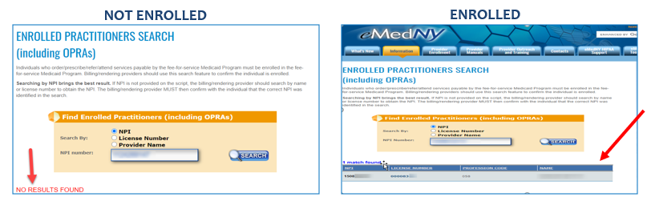
Search Screen Link: https://www.emedny.org/info/opra.aspx

- The agency can also check the following listings for current and/or pending OPRA providers.

  - The Medicaid Pending Provider Listing (Pending_Provider_File.xlsx (live.com))
This listing is for providers that have applied for OPRA enrollment that are in “pending” status. This listing will give you the date that eMedNY received the application and the Electronic Tracking Number (ETN) for the application.

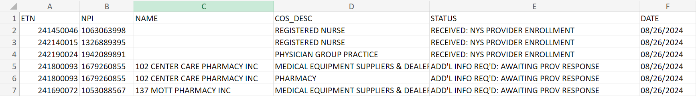

  - The Medicaid Enrolled Provider Listing (Medicaid Enrolled Provider Lookup | State of New York (ny.gov)) This listing is for providers that are currently enrolled. This listing will give you the provider’s Medicaid Provider Number, initial enrollment date and the date of the next anticipated Revalidation.

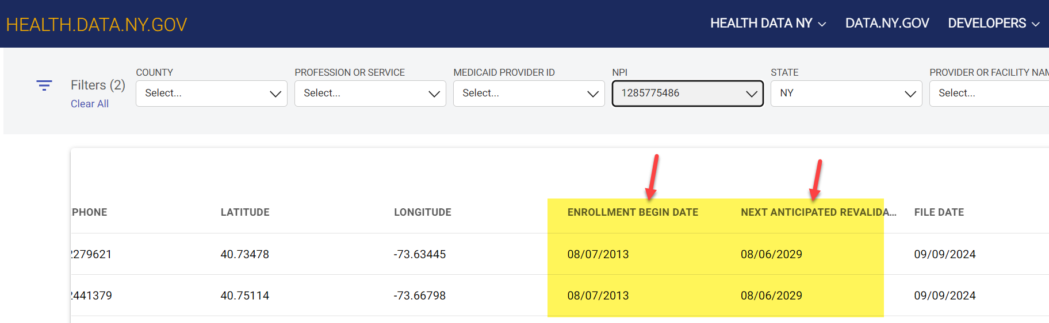

- If the newly-hired SLP is not OPRA enrolled, the agency may want to include the OPRA application as part of the onboarding documentation and address this with the SLP’s orientation to the agency.

Link to the OPRA Enrollment Application – Select Option #2: Provider Enrollment - Therapist (emedny.org)
- For new hires that are OPRA enrolled, the agency should request a copy of the SLP’s eMedNY Welcome Letter and/or request the SLP’s Medicaid Provider # for the agency’s records.

NEWLY LICENSED
- For CFYs and speech teachers that obtain their license, the Agency should assist the newly-licensed SLP in locating the online OPRA Enrollment Form or the Agency may want to keep blank applications on hand.

Link to OPRA Enrollment Application (Option #2): Provider Enrollment - Therapist (emedny.org)

Link to OPRA Information in the Portal Knowledge Base: https://support.cpseportal.com/kb/a255/opra-enrollment-information-website.aspx
- The agency should ensure that the OPRA application is completed and submitted to eMedNY as soon as the SLP receives their NYS license.*

*A copy of the SLP’s license will need to be submitted with the application form. CFY’s and speech teachers cannot apply for OPRA until they are licensed.

NEW CONDITIONAL APPROVAL PROCESS
After issuing many conditional approvals for non-enrolled OPRA providers, McGuinness has noticed that as long as billing can be submitted to the County, there is no urgency in becoming OPRA enrolled.
As a result, the Conditional Approval Process for non-enrolled OPRA providers is changing (effective September 2024). Instead of assigning a 180-day conditional approval period for non-OPRA providers to become enrolled, the county will be moving forward as follows:
- McGuinness receives Medicaid denials for a non-OPRA enrolled provider.
- Based upon the Medicaid denials, the SLP and the agency will be notified that the SLP needs to enroll in OPRA (to prevent future denials).
- The SLP will be assigned a 30-day conditional approval period to submit their OPRA application to eMedNY. (The agency will be able to bill during this 30-day period.)
- 7-10 days after the OPRA application has been submitted, the SLP or the agency can obtain a tracking number and day number from eMedNY (800-343-9000) for the application. The SLP or agency will email McGuinness (Medicaid@cpseportal.com) with the tracking and day numbers.
- After McGuinness receives the SLP’s application tracking information (above), the SLP will be given a 180-day conditional approval extension period while the SLP awaits their OPRA approval and Medicaid number (from eMedNY).
- If the SLP or agency does not report the tracking information to McGuinness and the 30-day conditional approval period expires, the conditional approval period will not be extended until McGuinness receives the eMedNY tracking information. This will impact the agency’s ability to submit billing for the children on the non-enrolled SLP’s caseload.
- Important Note:
  - If the SLP’s OPRA application is returned due to missing information, the agency should ensure that the SLP fills in the missing information as soon as possible and re-submits the completed application to eMedNY (before the 30-day conditional approval period expires).
  - As soon as McGuinness receives the tracking information for the application, the SLP’s conditional approval period will be extended to 180 days.

CONDITIONAL APPROVAL TRACKING
Considering that the agency will now experience billing issues due to non-compliance, it would be a benefit if the agency takes more of role in monitoring the OPRA Process.
Listed below are suggestions for tracking the OPRA Process.
- 7-10 days after mailing the application to eMedNY the SLP or the agency should call (800-343-9000) or email (Contact (emedny.org)) eMedNY to obtain a Tracking Number and a Day Number for the application. (The SLP’s NPI # is required for this inquiry.)
- Application processing for OPRA takes 90 to 120 days. The Application Day # will give an idea of where the SLP is in the process.
- The agency may want to maintain a spreadsheet that includes…
  - The date that the application was mailed
  - The date that eMedNY received the application and assigned the tracking information
  - The Medicaid #
  - The Initial Enrollment Date
  - The Next Revalidation Date
  - Comments – To keep track of the date mailed, day #, tracking #, etc.
Example Spreadsheet
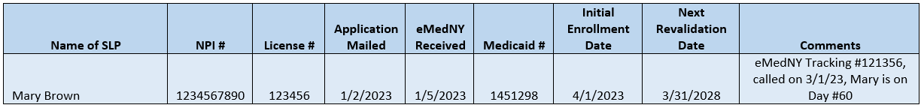

eMedNY OPRA APPLICATION PROCESS

The non-enrolled OPRA provider should complete the OPRA Provider Enrollment Application – Option #2 (for Service Providers). There is no cost to apply for Service Providers.
There are instructions for completing the OPRA Provider Enrollment Application (link to instructions below).
See screenshots of application and instructions on the next page.

Link to Application:
Provider Enrollment - Therapist (emedny.org)

Link to Instructions for Completing the Provider Enrollment Form:
INSTRUCTIONS FOR COMPLETING A NEW YORK STATE ENROLLMENT FORM FOR (emedny.org)

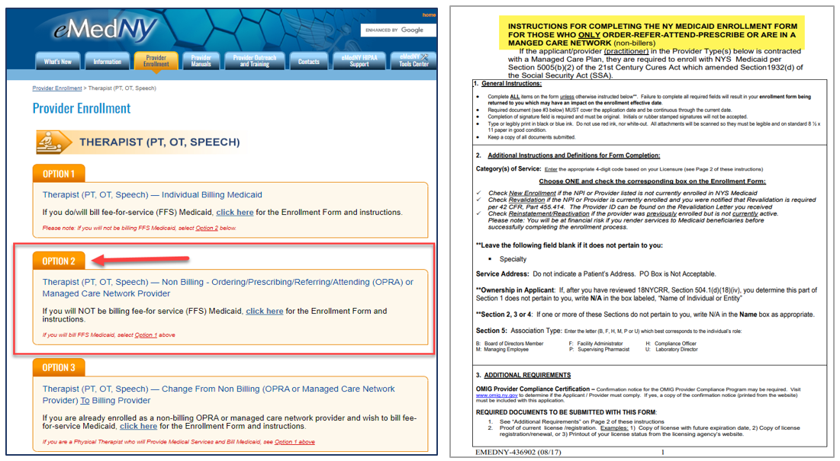

When you complete the enrollment application, you will need to check one of the three options shown below:
New Enrollment – Revalidation – Reinstatement/Reactivation
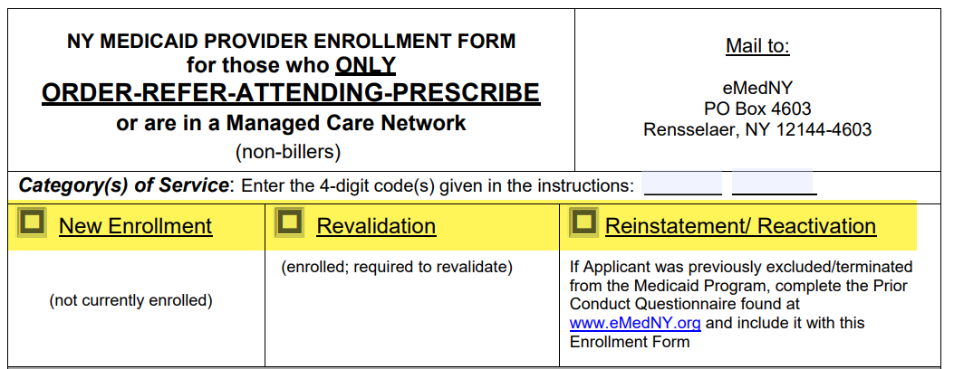

ENROLLMENT FORM – PAGE 2 (See screenshot of the OPRA Application on next page)
- Applicant Name - Fill in the applicant’s information.
- Correspondence Address – Fill in the address where the applicant will receive mail regarding the eMedNY application and all future eMedNY correspondence.
- Service Address – Fill in the address(es) where the applicant is employed. If the provider works in more than one agency, another agency can be listed on the Enrollment Form.
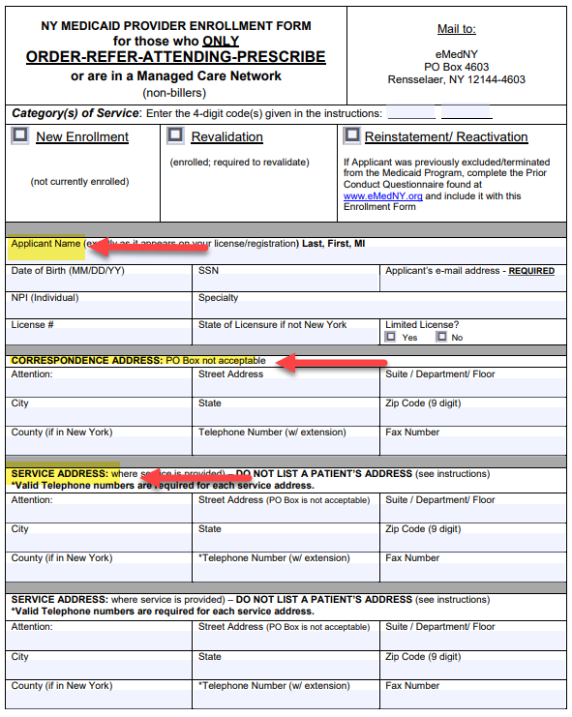

SECTIONS 1- 6 (Pages 3-4 – If you do not own a business, enter N/A for items 2 through 5.)*
- Applicant - Fill in the applicant’s information. Ownership in Applicant – This section is completed if the applicant has ownership in a business. If it does not apply, enter N/A.
- Ownership in Other Disclosing Entities – If you do not own a business this will not apply to you.
- Ownership in Subcontractors – If you do not own a business this will not apply to you.
- Familial Relationship in Subcontractors – If you do not do not own a business this will not you.
- Managing Employees & Those with Control Interest – If you do not do not own a business this will not apply to you.
- Make sure you answer all the questions in Section 6. (If it does not apply, enter N/A.)
*If you do own a business or have controlling interest in a business, you will need to complete Part two of Section 1 and Sections 2 through 5. See screenshots on next page. (You will find additional information about Sections 2-5 following the screenshots.) If a question does not apply, write N/A for the question.
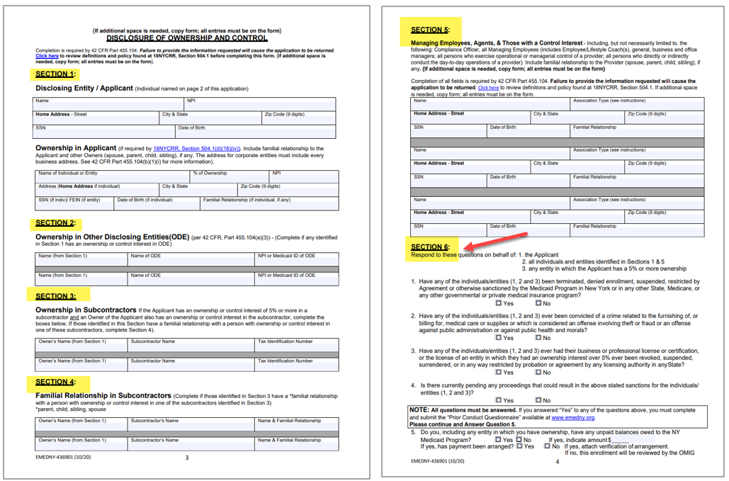

Sections 2 – 5 on the application are for applicants that own a business or have controlling interest in a business. Please see Section 504.1(d)(18)(iv) for more information (https://regs.health.ny.gov/content/section-5041-policy-and-scope).
…Person with an ownership or control interest means a person who owns an interest of five percent (5%) or more in any mortgage, deed of trust, note, or other obligation secured by the provider if that interest equals at least five percent (5%) of the value of the property of assets of the provider…

Signature & Affirmation
- The applicant must sign the Enrollment Form with an original signature in blue or black ink.
- The Signature & Affirmation Form must be dated.
- The name and telephone number of the person who prepared the Enrollment Form must be completed.
- See screenshot on next page.

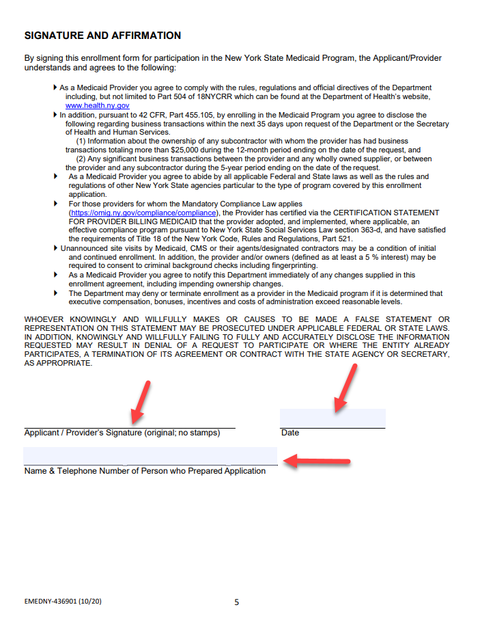

If the SLP cannot determine whether a question should be answered on the enrollment form, reviewing the Frequently Asked Questions (for OPRA Provider Enrollment) may help. (See screenshot on next page.)
Link to FAQs: Core_OPRA_FAQs.pdf (emedny.org)
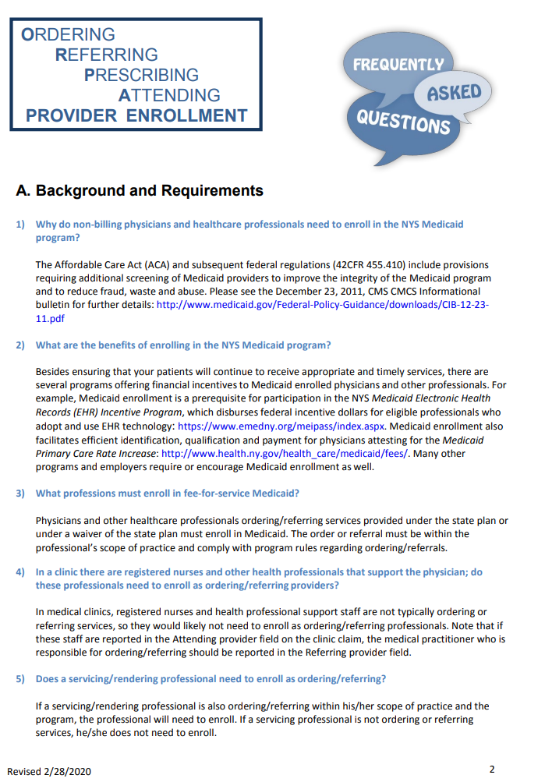

GENERAL INSTRUCTIONS FOR THE OPRA ENROLLMENT APPLICATION – Provider Enrollment - Therapist (emedny.org)

- Complete all items on the form. Failure to complete the required fields will result in the Enrollment Form being returned, which may have an impact on the enrollment effective date (and the Agency’s billing).
- An original signature is required. Initials or stamped signatures including font substitutions will not be accepted.
- Type or legibly print in black or blue ink. Do not use red ink, white-out or correction tape. Attachments need to be scanned on standard 8-1/2 x 11 paper.
- A copy of the SLP’s most recent NYS License must be included with the Enrollment Form
- Keep a copy of all documents submitted – requests for copies will not be honored.

ADDITIONAL INSTRUCTIONS FOR THE OPRA ENROLLMENT APPLICATION FORM (eMedNY Website)
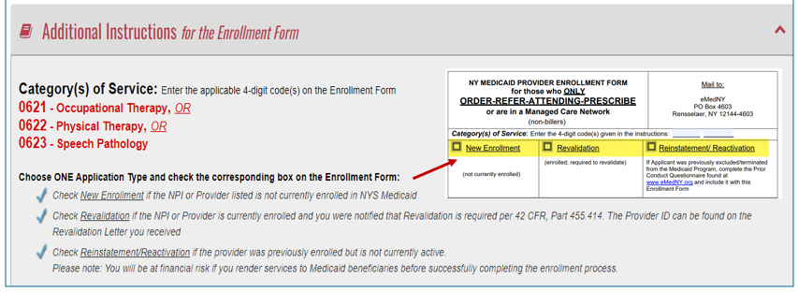

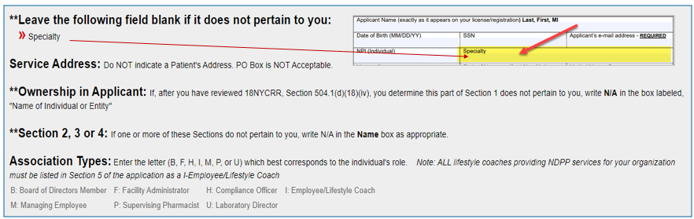

ADDITIONAL FORMS & REQUIREMENTS (eMedNY Website)

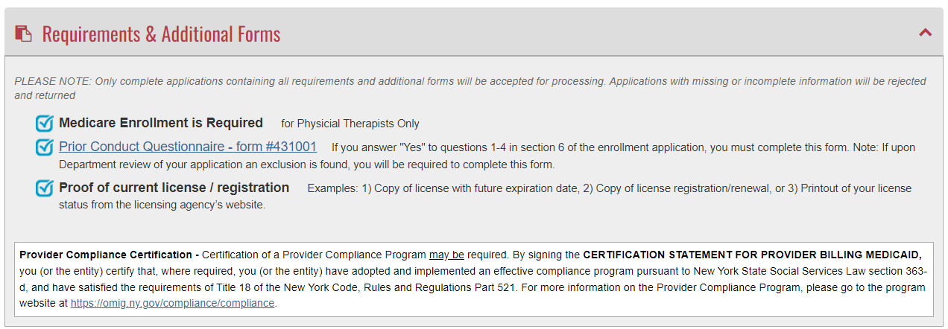
MAINTENANCE FORMS (eMedNY Website)
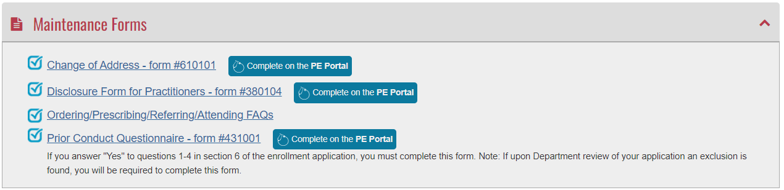

ENROLLMENT APPLICATION MAILING ADDRESS
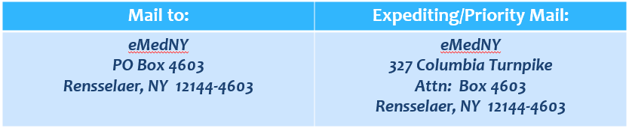

OPRA INITIAL ENROLLMENT DATE

- When the SLP receives their Welcome Letter (and Medicaid Provider #), the SLP should give a copy of the letter to the agency (for the agency’s records).
- The SLP or agency should email a copy of the Welcome Letter to McGuinness (Medicaid@CPSEPortal.com) so Medicaid Denials for non-OPRA enrollment can be rebilled.
- The agency should also keep a spreadsheet that includes…
  - The SLP’s Medicaid Provider #,
  - Initial Enrollment Date
  - The SLP’s Next Revalidation Date

- The agency will want to follow-up with the SLP regarding Revalidation so the SLP’s OPRA enrollment is not terminated.

eMedNY REVALIDATION PROCESS

- It is important to note that OPRA enrollment needs to be revalidated every five (5) years from either the enrollment effective date (as specified in the Medicaid Welcome Letter) or the last date revalidation was completed (as indicated on the Successful Completion of Revalidation Letter).
- It is important that providers keep their address current with eMedNY so the they receive the Revalidation Letter.
Link to eMedNY Change of Address Form:
https://www.emedny.org/info/ProviderEnrollment/ProviderMaintForms/610101_BPGCOA_FRM_Address_Change_Form.pdf

STAGES OF REVALIDATION

- Initial Revalidation Letter – Revalidation documentation should be sent to eMedNY within 90 days of the date of the Initial Revalidation Letter.

- Final Revalidation Letter – If the SLP does not respond to the “Final Revalidation Letter” within 45 days, the provider’s OPRA enrollment will be terminated.

- Revalidation Letter Received – When the Revalidation Letter is received, the revalidation will be reviewed by the Bureau of Provider Enrollment. No further action is required unless contacted by the Bureau. A letter will be sent once the revalidation process is completed.

- Successful Revalidation Letter – When the submitted revalidation is approved, a “Successful Revalidation Letter” is sent to the provider. The next revalidation is due (5) five years from the date on this letter. Five years from the date of this letter is when the SLP will need to revalidate. This date should be monitored by the agency to ensure that OPRA enrollment is not terminated.

WHAT HAPPENS NEXT?

After the revalidation submission is received by eMedNY, the applicant will receive a written notice that the Revalidation Packet was received. Next Steps Include…

Prescreening by eMedNY
- If there are errors on the application form or the packet is incomplete, the entire revalidation packet will be returned (to the applicant) by mail with a checklist that details what is required. The packet should be completed and re-sent to eMedNY for re-screening.

- If no errors are detected, the revalidation application will be scanned and entered into the eMedNY system. This may take 2-3 weeks from receipt. You may contact eMedNY for an Enrollment Tracking Number (ETN) for the Revalidation.

- When the submitted Revalidation Application is approved, a “Successful Revalidation Letter” will be sent to the address on the application. The next Revalidation will occur (5) five years from the date on this letter.

WHAT SHOULD YOU DO IF YOU DO NOT RECEIVE YOUR REVALIDATION LETTER?
- It is very important that the provider notify eMedNY of an address change so their OPRA enrollment is not terminated.

Link to eMedNY Change of Address Form:
https://www.emedny.org/info/ProviderEnrollment/ProviderMaintForms/610101_BPGCOA_FRM_Address_Change_Form.pdf

- If the SLP is within 60 days of their revalidation date and the SLP has not received the Initial Revalidation Letter, the SLP or the agency should reach out to eMedNY (800-343-9000) to find out what is needed to revalidate enrollment.
- If the SLP’s OPRA enrollment is terminated, the SLP will need to submit an OPRA Re-Instatement/Re-Activation Application along with a Prior Conduct Questionnaire, which can take up to four months to process (along with an additional Conditional Approval Period that may affect billing).

ENROLLMENT TERMINATED – HOW DO YOU BECOME ACTIVE AGAIN?
I recently received a notice that my enrollment has been terminated because I did not revalidate. How do I become an active Medicaid provider again?
- Complete the Revalidation Enrollment Form (Provider Enrollment - Therapist (emedny.org)) for your provider type and mail to eMedNY.

- 7-10 Days after mailing your Revalidation Enrollment Form to eMedNY, call the eMedNY Call Center Help Desk at 800-343-9000 to confirm receipt of your Revalidation Enrollment Form. Ask for a 9-digit Enrollment Tracking Number (ETN).

- Write the provider mailbox at providerenrollment@health.ny.gov and state that you have revalidated and wish to be reactivated. Provide your Enrollment Tracking Number (ETN).

- Only with a confirmed tracking number (ETN #) will eMedNY reactivate your enrollment.

When the provider’s enrollment in the eMedNY Program is terminated for failure to respond to the Initial and Final Letters, a Reinstatement/Reactivation Enrollment Application is required. A Prior Conduct Questionnaire must also accompany the Reinstatement Enrollment Application.
Links:
Reinstatement/Reactivation Enrollment form: Provider Enrollment - Therapist (emedny.org)
Prior Conduct Questionnaire: Email Template (emedny.org)

Make sure you select the Reinstatement/Reactivation Enrollment Type on the Enrollment Form.
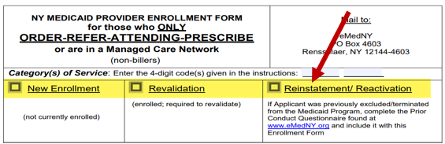
You will also need to complete the Prior Conduct Questionnaire.
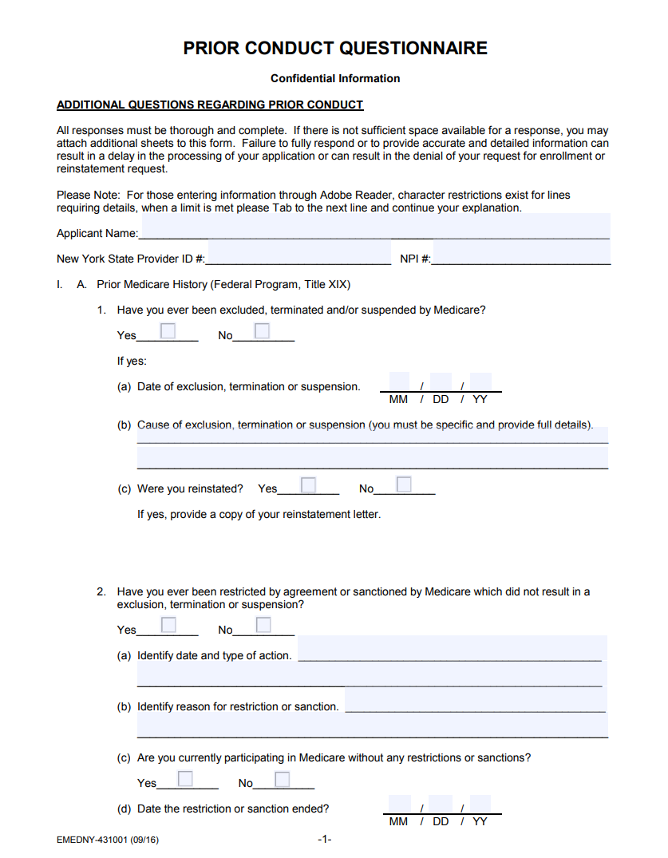

Check a Provider’s Next Revalidation Date
You can check a provider’s next anticipated revalidation date using this link. (https://health.data.ny.gov/Health/Medicaid-Enrolled-Provider-Listing/keti-qx5t/data). Click the Search Icon (upper right-hand corner) and enter the provider’s NPI #.
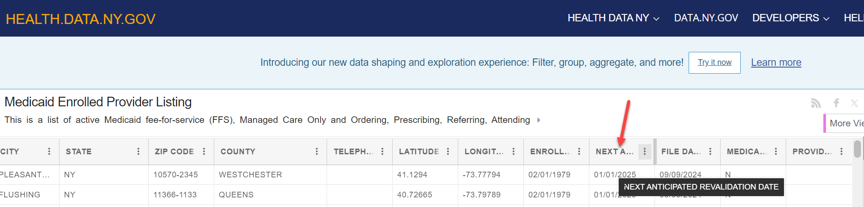
Revalidation Frequently Asked Questions (FAQs)
You can review a list of Frequently Asked Questions (for Revalidation) using this link (Revalidation - Frequently Asked Questions (emedny.org)) You can scroll through all of the questions or you can use the Search feature to narrow your search.

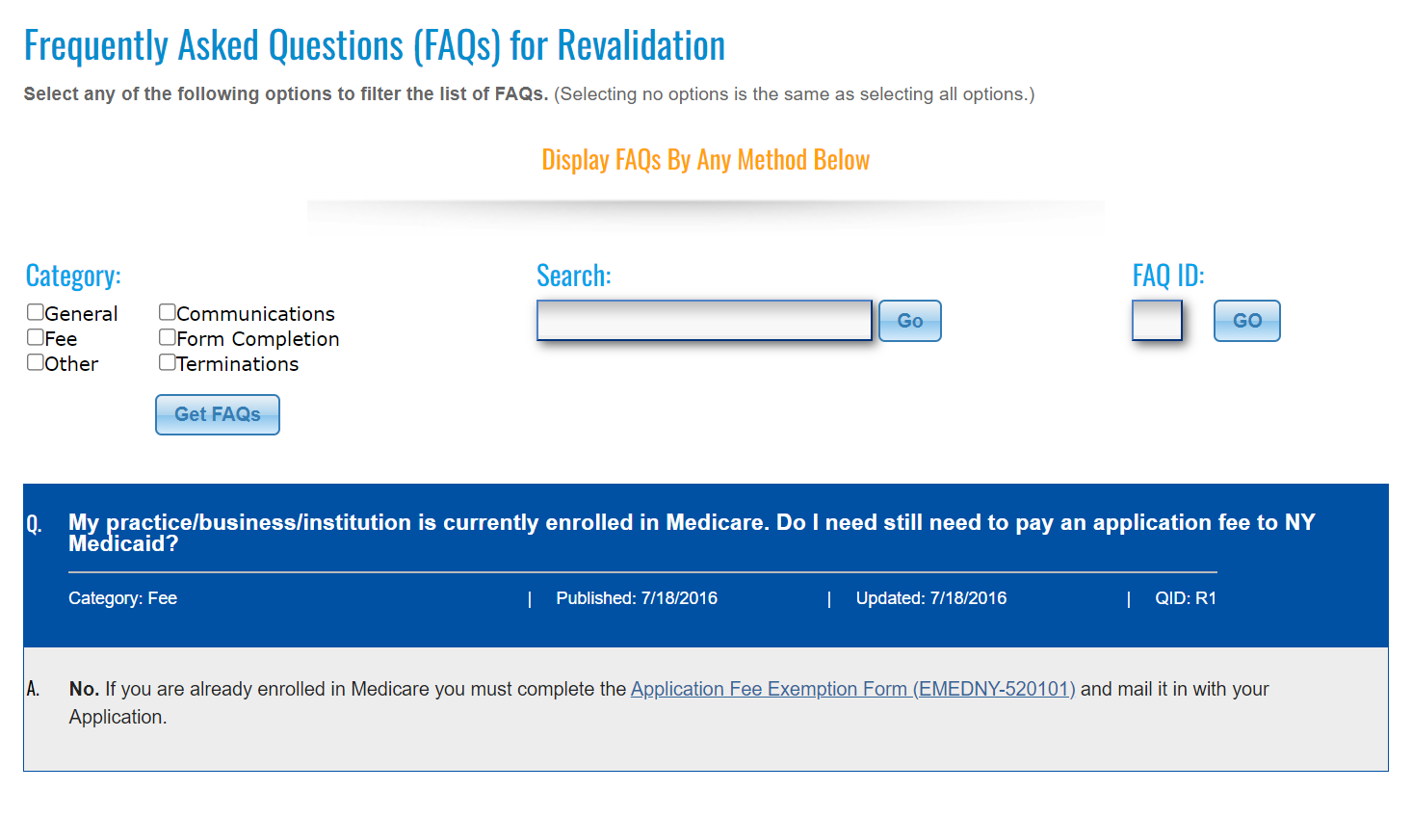

Revalidation Mailing Address
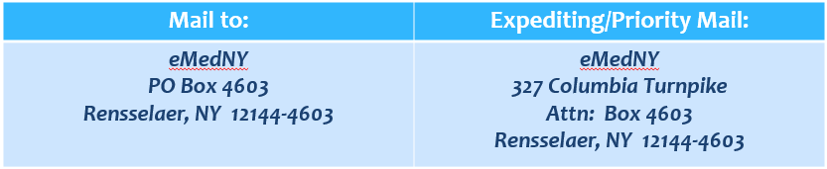

SAMPLE REVALIDATION LETTERS
Initial Revalidation Letter
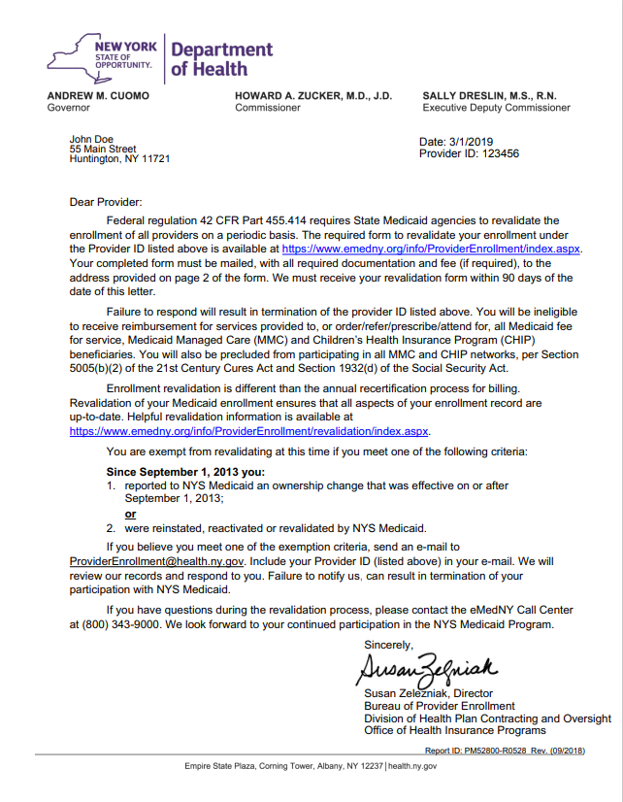

Final Revalidation Letter
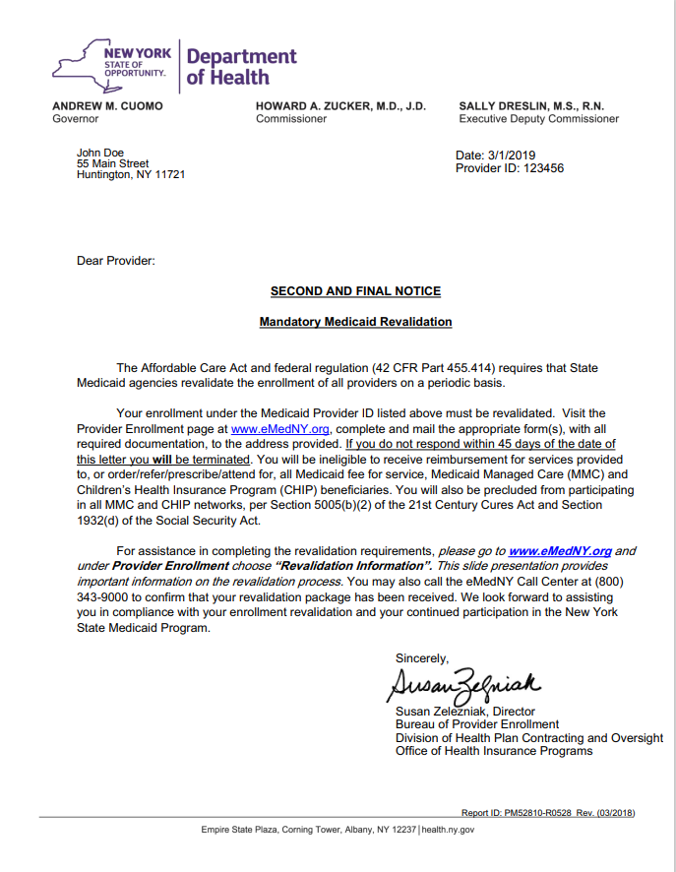

Successful Revalidation Letter
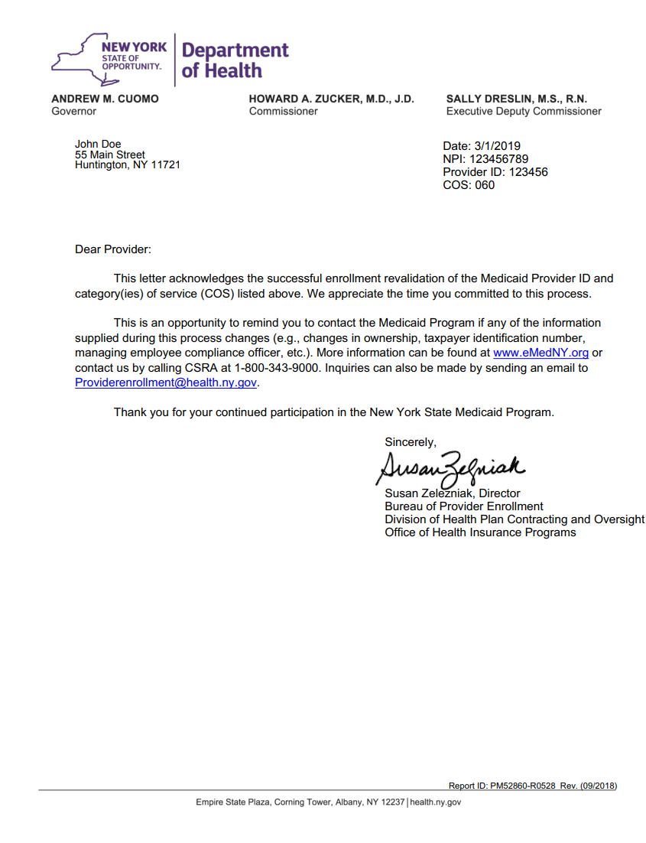

MEDICAID COMPLIANCE WITH A NON-ENROLLED OPRA PROVIDER

If your agency has a non-OPRA enrolled provider servicing children, you may want to assign an OPRA-enrolled SLP to the child so the OPRA enrolled provider can conduct one session with the child (as required by Medicaid – Medicaid Q&A #94) to assess and diagnose the child.
After the one session has been completed, the SLP should create a digital speech recommendation for the child and complete one session note for the initial session.
Since the referral will be written by an OPRA-enrolled SLP, the non-enrolled OPRA provider will be able to service the child while meeting the county’s Medicaid requirements.

CONTACT INFORMATION

eMedNY Contact Information

- eMedNY Call Center – 800-343-9000 (You will need the provider’s NPI # for the call.)

- eMedNY – Email Submission Form - Contact (emedny.org)

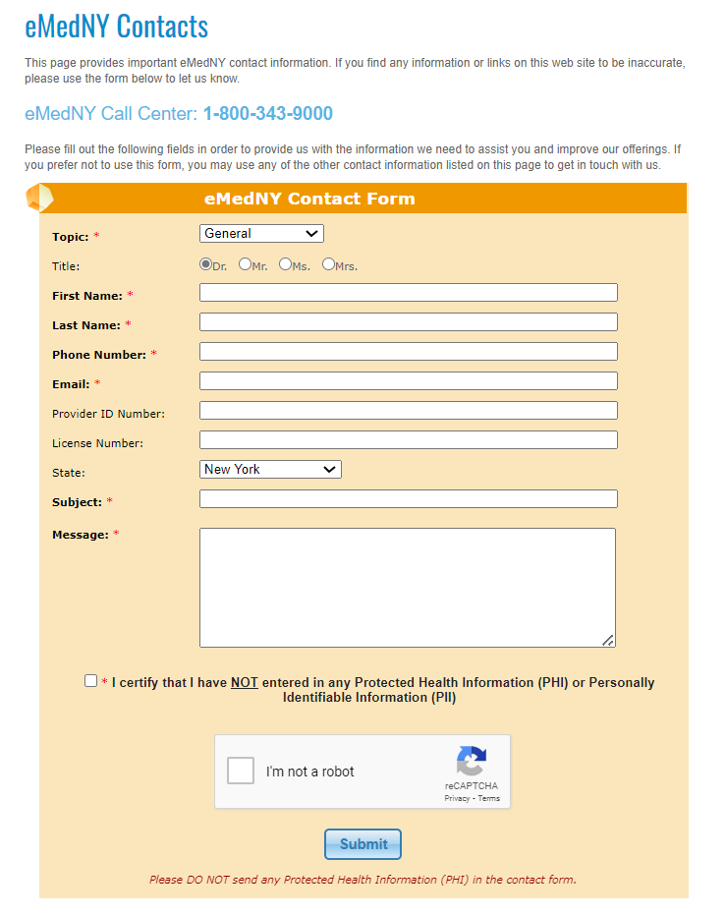

McGuinness Contact Information
Medicaid Support: Medicaid@CPSEPortal.com
Deborah Frank: dfrank@jmcguinness.com or 518-393-3635, Ext. 41

MEDICAID REFERENCES

Medicaid Questions & Answers
https://www.oms.nysed.gov/medicaid/q_and_a/q_and_a_combined_revised_12_9_16.pdf

- Q&A #94 – Timing for writing a referral for an SLP
- Q&A #204 – OPRA
- Q&A #206 – OPRA
- Q&A #219 – OPRA

IMPORTANT OPRA LINKS

eMedNY Change of Address Form: https://www.emedny.org/info/ProviderEnrollment/ProviderMaintForms/610101_BPGCOA_FRM_Address_Change_Form.pdf

Reference | Link
eMedNY CONTACT INFORMATION
eMedNY Call Center Phone Number | 800-343-9000
eMedNY Contact Screen | Contact (emedny.org)
eMedNY SEARCH SCREENS
eMedNY Search Screen | https://www.emedny.org/info/opra.aspx
Medicaid Enrolled Provider Lookup | Medicaid Enrolled Provider Lookup | State of New York (ny.gov)
Medicaid Pending Provider Listing | Pending_Provider_File.xlsx (live.com)
eMedNY ENROLLMENT INFORMATION
eMedNY Enrollment Form – Option #2 | Provider Enrollment - Therapist (eMedNY.org
eMedNY Enrollment Form Instructions | instructions for completing a new york state enrollment form for (emedny.org)
Enrollment Form General Instructions | Provider Enrollment - Therapist (emedny.org)
Prior Conduct Form | Email Template (emedny.org)
OPRA Frequently Asked Questions | Core_OPRA_FAQs.pdf (emedny.org)
EMedNY REVALIDATION
Revalidation Frequently Asked Questions | Revalidation - Frequently Asked Questions (emedny.org)
Stages of Revalidation Letters | Revalidation (emedny.org)
Prior Conduct Form | Email Template (emedny.org)
Next Anticipated Revalidation Date Listing | https://health.data.ny.gov/Health/Medicaid-Enrolled-Provider-Listing/keti-qx5t/data
REGULATIONS
Regulation | Link
Ownership in Applicant (Section 1)  Section 504.1(d)(18)(iv) | https://regs.health.ny.gov/content/section-5041-policy-and-scope
Disclosure of Ownership & Control (Section 2)  42 CFR Part 455.104(a)(3) | https://www.ecfr.gov/current/title-42/chapter-IV/subchapter-C/part-455/subpart-B/section-455.104

MCGUINNESS
Medicaid Email | Medicaid@CPSEPortal.com
OPRA Enrollment Information in Portal  Knowledge Base | https://support.cpseportal.com/kb/a255/opra-enrollment-information-website.aspx

